Pervasive climate change impacts on zooplankton: Meta-analyses of observations, experiments and models

Supplementary Methods
Experimental data

Data collation
We compiled data from existing meta-analyses published in recent years that examined the effects of temperature, ocean acidification, and their interaction effects on marine organisms with planktonic life stages, including both holoplankton and meroplankton. We first used Jian et al. (2025) as the starting database, followed by Alter et al. (2024), because these studies included broad literature searches on climate change impacts on marine life. For the succeeding meta-analyses we collated, we checked whether each record from those references was already present in our working database and only added records that were new. In total, we found 11 different meta-analyses that included experimental records of climate change impacts on zooplankton, which are listed down in the database References sheet.

For meroplanktonic organisms, we only included entries corresponding to planktonic early life stages, including eggs, embryos, larvae, postlarvae, gametes, or fertilisation stages, depending on how these were reported in the source database. Juvenile and adult stages were excluded unless the organism was holoplanktonic. For holoplankton, we retained records for taxa that remain planktonic throughout their life cycle. The exact steps that show how each meta-analysis reference were filtered for which subset of data were added onto our database are enumerated in the found in the Appendix A of this document.

Response variables were grouped into five broad categories: growth, development, physiology, reproduction, and survival (Table 1). Because the existing meta-analyses used varying response classifications, we selected the smallest set of representative categories that captured distinct biological processes while retaining sufficient records to provide meaningful summaries of the overall trends.

Table 1. Definitions for each response categories.
Final Categories | Working definition
Growth | Changes in body size, length, mass, biomass, or growth rate.
Development | Progression through life stages, timing of development, morphology, abnormalities, or settlement.
Physiology | Metrics that reflect internal functioning, organism condition, or observable activity, including metabolism, respiration, enzyme activity, oxidative stress, calcification, shell condition, energy reserves, swimming activity, feeding behaviour, predator avoidance, and movement.
Reproduction | Responses related to reproductive output or investment, including fecundity, egg production, spawning, fertilisation success, gonad condition, reproductive effort, and hatching success.
Survival | Persistence, mortality, abundance, density, or population/count-based endpoints.

Data filtering
Duplicate records identified during database collation were removed. From an initial count of 4866 records, 4392 records remained. We then filtered records based on the magnitude and direction of the experimental treatment relative to the control. Specifically, pH-only records were retained when 0 < ΔCO₂ < 1600 ppm, and temperature-only records were retained when 0 < ΔT ≤ 8°C, where ΔCO₂ and ΔT were calculated as the treatment-minus-control difference in CO₂ concentration and T, respectively. For combined temperature and acidification treatments, records were retained only when both criteria were met. These thresholds were used as conservative upper bounds to remove extreme treatment conditions, while at the same time, retaining experiments that were broadly relevant to climate-change exposure scenarios e.g. within the expected atm ppm and oceanic T for SSP5-8.5 (ref). This filtering resulted in 3,398 records. The database was further screened to retain only records involving zooplankton and to exclude records that did not meet the study’s eligibility criteria. Reasons for exclusion included treatment variables outside the scope of this study (e.g. oxygen or pH alone, or temperature combined with oxygen or other variables) and missing mean or control response values, bringing the valid records to 3,375.

Meta-analysis
For each comparison, we calculated the log respose ratio (lnRR) as the effect-size metric:

$$lnRR_{i}=ln\left(\frac{{\overline{X}}_{T_{i}}}{{\overline{X}}_{C_{i}}}\right)$$

where ${\overline{X}}_{T_{i}}$ and ${\overline{X}}_{C_{i}}$are the treatment and control means, respectively. The corresponding sampling variance was calculated as:

$$v_{i}=\frac{SD_{T_{i}}^{2}}{N_{T_{i}}{\overline{X}}_{T_{i}}^{2}}+\frac{SD_{C_{i}}^{2}}{N_{C_{i}}{\overline{X}}_{C_{i}}^{2}}$$

where ${SD}_{T_{i}}$ and ${SD}_{C_{i}}$ are the treatment and control standard deviations, and $N_{T_{i}}$ and $N_{C_{i}}$ are the treatment and control sample sizes. Effect sizes were retained only when the treatment and control means permitted calculation of the log response ratio, both the effect size and sampling variance were finite, and the sampling variance was greater than zero. Following these exclusions, 3,313 effect sizes were retained in the primary meta-analysis.
For response variables in which higher values represented poorer biological performance (e.g. mortality or abnormalities), effect sizes were multiplied by −1. Consequently, negative lnRR values consistently indicated poorer biological performance under experimental conditions, whereas positive values indicated improved performance. Response variables whose direction could not be determined from the original study or existing meta-analysis were classified as ambiguous and excluded from the primary analysis. This brought the number of effect sizes included in the primary analysis to 2,495.

Acidification and warming were represented by binary indicator variables denoting whether each stressor was absent (0) or present (1) in a treatment. Acidification-only treatments were therefore coded as A = 1 and W = 0, warming-only treatments as A = 0 and W = 1, and combined acidification and warming treatments as A = 1 and W = 1.

We estimated model-predicted mean lnRR and associated 95% confidence intervals using multilevel meta-analytic models fitted with the rma.mv() function in the metafor package in R (Viechtbauer, 2010). Models were fitted without an intercept using restricted maximum likelihood estimation, following Jian et al. (2025). Acidification, warming, and their interaction were included in a single model:

$$y_{i}=β_{A}A_{i}+β_{W}W_{i}+β_{\left(A:W\right)\left(A_{i}W_{i}\right)}+u_{Study\left[i\right]}+u_{ES\left[i\right]}+ε_{i}$$

where $y_{i}$ is the direction-adjusted lnRR for effect size $i$; $A_{i}$and $W_{i}$ indicate the presence or absence of acidification and warming, respectively; $β_{A}$and $β_{W}$represent the mean effects of acidification and warming; and $β_{\left(A:W\right) }$represents the interaction between them, or the additional effect of their combined application beyond the sum of their individual effects. The terms $u_{Study\left[i\right]}$and $u_{ES\left[i\right]}$represent random intercepts for the study containing effect size $i$ and for effect-size identity nested within study, respectively, following Jian et al. (2025). The sampling errors, represented by $ε_{i}$, were modelled using the sampling variance–covariance matrix $V.$

Under this parameterisation, the predicted effects of acidification-only and warming-only treatments were $β_{A}$and $β_{W}$, respectively. The predicted effect of combined acidification and warming was estimated as the following linear combination:

$$ŷ_{A:W}=β_{A}+β_{W}+β_{A:W}$$

The 95% confidence interval for the combined effect was calculated using the variances and covariances of the three estimated coefficients. The interaction coefficient, $β_{\left(A×W\right)}$, was interpreted separately as the departure of the combined response from additivity on the lnRR scale.

When multiple treatment comparisons used the same control group, their sampling errors were treated as correlated. For two effect sizes, \(j\) and \(k\), sharing the same control group, the sampling covariance was calculated from the contribution of the shared control:

$$Cov\left(y_{j},y_{k}\right)=\frac{SD_{C}^{2}}{N_{C}{\overline{X}}_{C}^{2}}$$

These covariance terms were incorporated into the sampling variance–covariance matrix V. Comparisons that did not share a control group were assigned a covariance of zero. When the sign of an effect size was reversed to standardise its biological interpretation, the corresponding row and column of V were adjusted using the same direction multiplier.

The model was first fitted to the complete dataset. Separate models were subsequently fitted for each response category (growth, development, physiology, reproduction, and survival) and each calcification group (calcifier and non-calcifier). The number of studies and effect sizes contributing to each model was reported alongside the corresponding results.

Studies were not required to include a complete factorial design containing control, acidification-only, warming-only, and combined treatments. Consequently, the main effects and combined-treatment response were estimated using all available valid comparisons. The interaction coefficient therefore represented a model-based contrast across the available evidence and was not estimated exclusively from within-study complete factorial contrasts.

To assess the influence of ambiguous response variables, we conducted two sensitivity analyses in which these observations were added back to the dataset. In the first analysis, ambiguous responses were treated as variables for which higher values indicated improved biological performance, and their signs were not reversed. In the second analysis, they were treated as variables for which higher values indicated poorer biological performance, and their signs were reversed. Both sensitivity analyses otherwise used the same model structure and sampling variance–covariance specification as the primary analysis.

Appendix

- Subsetting of existing meta-analyses references for inclusion in our database.

- Alter et al. 2024: Invertebrates Dataset
- Filter all columns > Go to LifeStage > and only enable EMBRYO, LARVA, AND POSTLARVA (924)
- Since there are other invertebrates that may be HOLOPANKTONIC, extract the unique species values for ADULT, JUVENILE, JUVENILE/ADULT, and use AI (ChatGPT) to identify which ones are holoplanktonic => Check this whether it already exists with Jian’s dataset => All already exists (0)

- Jian et al. 2022
For zooplankton:
- Filter columns > Ecosystem_category == Marine > Biota_Group == Zooplankton (retrieved 350)
- One entry under Towle, Erica K. et al., 2016 was categorised under Zooplankton but was transferred to Meroplankton (349)

For fish and invertebrae:
- Filter columns > Ecosystem_category == Marine > Biota_Group == Fish & Invertebrae (retrieved 259)
- For these remaining studies, look at first whether they already exist in Alter or not. If not:
- Check whether the reference studied meroplankton stage or not (look up the study itself). If they did not look at meroplanktonic stage, on the link column, note this down.
- Moreover, exclude juveniles (i.e., Kikkawa et al. 2003)
- Using this schematic, only 127 retrieved.
- Since Hoshijama U et al. 2017 look at pteropods, this was transferred to holoplankton, thus the remaining retrieved entries is just (123)

- Hoppit et al. 2022
- Filter columns > In the column taxonomy, disable the following: Seagrass, Algae, calcifying algae => 514 studies
- Under organism, look up which species are holoplanktonic and enable them only, and this include the following (29) 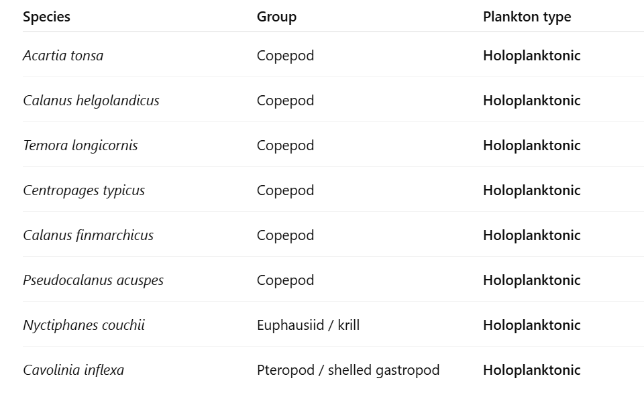
- Then check whether each of these already exists in the current database => all are new (29)
- Now, under organism, disable all the holoplanktonic species, and then under the column dev_stage, disable the adults and juvenile and na (technically leave egg/larva) => 85
- Then check whether these studies are new
- The new ones => 55
- Thus, the total for Hoppit et al. combined is 84.

- Hu et al. 2024
- Filter columns > Go to LifeStage and enable embryo, egg, fertilization and larvae => 150 records
- Go to species column and identify which species don’t undergo planktonic stage and disable them => strict no include Sepia officinalis and Macrocystis spp. => 141 records remain
- Manually check whether such studies already exist in the database or not. If they already exist drop them => 51 records remain
- Now, clear all filters, and then go to species section, identify which species are holoplanktonic => Limacina spp., Neogloboquadrina, and marginopora => 12 records
- Identify whether they are new records or not => 12 records remained
- In total, 51 + 12 => 63 records retrieved

- Kindinger et al. 2022
- Filter columns > Go to Cons_taxa spec and then enable only those holoplanktonic species, which include these:
  - Copepod
  - Krill
  - Ciliate
  - dinoflagellate
- This results to 28 retrieved entries. Then identify what’s new => 24
- Then remove filter, and then got to Cons_taxa spec again, and then try to enable everything except for the holoplanktonic taxon groups and then under cons_lstage category, select larv => 32 entries, then check whether new => 20
- In total, 24 + 20 => 44 entries

- Kruft-Welton et al. 2024
- Filter columns > Go to developmental_stage == Egg/larva => 45 entries
- Check if new => 42 entries

- Lang et al. 2023
- Filter columns > Lifestage > select embryonic, larval, and gametes => 295 entries
- manually check if study already exists in the database (in reference to Alter et al.) => 242 entries

- Ross et al. 2024
- Standard protocol: Go to Life_stage > enable larval only > and then manually check if data already exists
- There are four spreadsheets
  - OA_Data_Size => 60 entries
  - OA_Mortality => 45 entries
  - T_Data_Size => 19 entries
  - T_Mortality => 37 entries

- Rynkowski et al.
- Filter columns > Life stage = larvae, embryo, gametes => 26 entries

- Hamraj et al. 2021
- There are several sheets in this database
- All the acidification related sheets are already reflected in Jian et al. 2025 => double checked and apparently not all the entries are reflected in Jian
  - Egg production => 79 records => 53 records after filtering out existing records
  - Survival => 22 entries => 3 entries
  - Respiration => 56 entries => 65 entries
  - Feeding => 26 entries => 17 entries
  - Egg hatching => 152 entries => 110 entries
- All the temperature related entries are new => 312 entries
  - Egg production => 121 entries
  - Egg hatching => 70 entries
  - Survival => 52 entries
  - Respiration => 46 entries
  - Feeding => 23 entries

- Leung et al. 2022
- Provided by the author himself

- Assigning the direction of the response

Following Alter et al. (2024), assigning the direction of response metric is important in correctly representing the log response ratios. Alter et al. (2024) used three categories: positive, negative, and ambiguous.

- Alter et al. (2024) for Invertebrates and Fish.
- They already had this column under MetricType.

- Jian et al. (2025)
- Column: Response_Biota, all of the metrics used across the studies were elaborate and detailed enough to assign the metrics accordingly to positive, negative, and ambiguous.

- Hoppit et al. (2022)
- Based on the column biologicalparameter
- However, the possible categories were just generic and general. For instance, growth, survival, reproduction, metabolic response, calcification, etc.
- Because of these, all of the records were assigned ambiguous.

- Hu et al.
- Based on the column CalculatedUnit
- Because the metrics were specific enough, they were assigned accordingly to positive, negative, and ambiguous
- Generally, those assigned negative were mortality

- Kindinger et al. 2022
- Based on the column Resp_spec
- All of the metrics were assigned as positive since behavioural metrics are generally more positive, the higher the metric (e.g. higher ingestion rate == better)

- Kruft Welton et al. 2024
- Based on the column measurement
- All were assigned positive since all were growth-related metrics.

- Lang et al. 2023
- Based on the column Measure
- Because the metrics were specific enough, they were assigned accordingly to positive, negative, and ambiguous
  - Generally, mortality, abnormality, developmental length time were assigned as negative.

- Ross et al. 2024
- Since the study did not provide any response metrics, the individual records were revisited to determine the metrics that were used in the study (revisited manually)

- Rynkowski et al. 2025
- Based on the column Response.Measurement
- Since the metrics were just general, all were assigned as ambiguous

- Hamraj et al. 2021
- The study did not provide specific metrics used. Instead, they just divided their dataset by categories (as reflected in the different tabs in their spreadsheet)
- Some studies were revisited; others were not (revisited manually but not complete)

- Leung et al. 2022
- Author provided all the specific metrics used by each study
- Because the metrics were specific enough, they were assigned accordingly to positive, negative, and ambiguous

